DTSC 671: AI Solutions in the Cloud

SUBMISSION TEMPLATE:
Object Recognition with Amazon Rekognition

Select File > Make a copy to edit the template and add your screenshots. Download the completed template as a PDF document to submit to Brightspace.

In every screenshot, include your AWS username that appears in the upper right corner. Example:

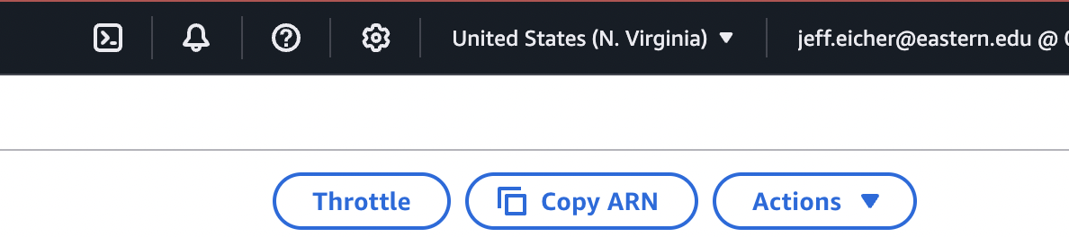

If any one screenshot is missing this identification, the entire assignment will be scored no higher than 70%.

Points totals are provided at the start of each question. You score either full credit or 0 points; there is no partial credit for each question.

- [5 points] In the space below, provide a screenshot of the image you selected and a description of where you found it (i.e., provide a website if you found the image online; or, if it’s your own picture, just let us know). The image should have multiple objects in it (at least three), rather than one single object.

- [10 points] In the space below, provide a screenshot of the Lambda function diagram (with trigger and destination).

- [10 points] In the space below, provide both a screenshot of the beginning of your Lambda code with your account showing, then copy-paste your full lambda code below the screenshot.

- [10 points] In the space below, provide a screenshot of the CloudWatch log streams for your Lambda function. Fit as many as you can in the screenshot.

- [10 points] In the space below, provide a screenshot of the CloudWatch stream that functioned without errors.

- [10 points] In the space below, provide a screenshot of IAM role permissions for the Lambda function.

- [20 points] In the space below, provide a screenshot of the JSON file in your output bucket.

- [25 points] Provide a screenshot of your JSON file’s output (which shows labels and confidence). Fit as much as you can in the screenshot. We expect this information to match the image you provided above.

